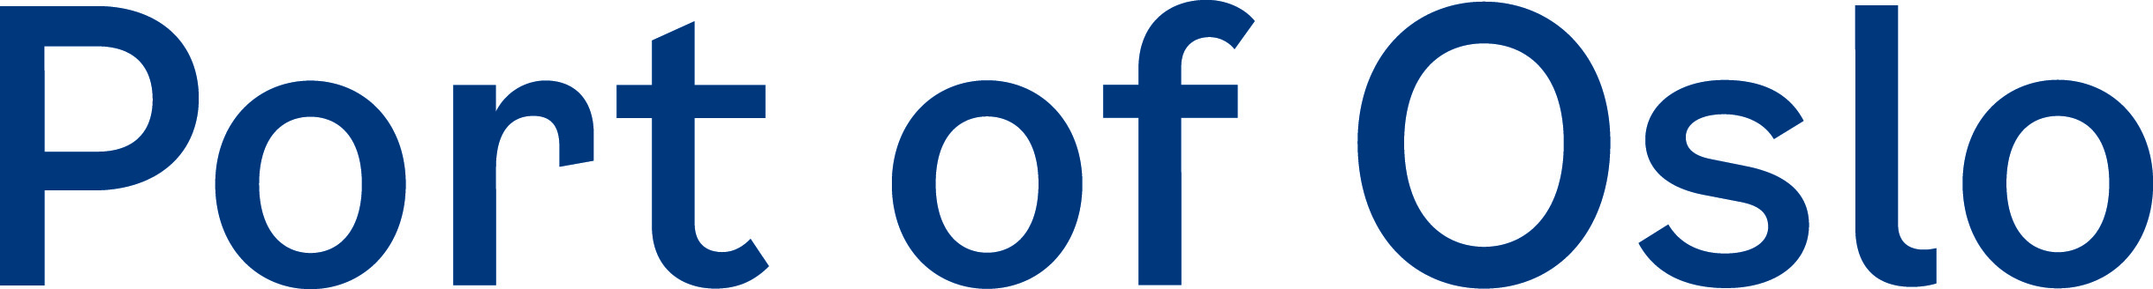

CERTIFICATE OF CONTAMINATION FREE SEWAGE WHILE IN THE PORT OF OSLO
The Port of Oslo provides a standard sewage hose of 100 mm (4’’) with a capacity of approximately 150 m³ per hour with a maximum pressure acceptable of 5 bar. If other dimensions are required to connect to ship, please specify below.
Ship name: ........................
IMO number: ........................
Date: .........................
Berth: Søndre Akershuskai (SAK)
Please be informed that the crew of the Port of Oslo or operator will not be on duty whilst pumping.
Dimensions of connections (specify if you have other connection than 4’’): .................................
Location of preferred sewage connection (foreward, midships or aft): ......................................
Bar pressure used from ship (1-5 Bar or kubikk per hour): .......................................
Estimated amount delivered ......................................
Total black/grey/permeat delivered (measured onboard): ...................................... m³
We hereby certify that the discharge from our ship, into the sewage pipe system in the Port of Oslo, is sewage only. It is therefore contamination free from other wastes or products such as oily wastes, food waste and grease, or harmful chemicals or other substances that can be harmful to sewage treatment plants.
If test results from the wastewater analysis are higher than the limits given by our municipality, who accepts the wastewater in their treatment plant, the port is entitled to charge an extra fee.

_________________________ _________________________
Chief engineer/Officer in charge Port of Oslo (or by operator in port)
Please send this form to: havnevakt@oslohavn.no minimum 24 hrs prior to arrival
Last updated 02.01.20 by Heidi Neilson in the Port of Oslo

